**Data Analysis on the Dating app: Tinder - Insights and Conclusions**

**Introduction**

This project involves analyzing data from a popular dating app named ‘Tinder’, to identify user behavior patterns and trends. The goal is to uncover insights that can help improve user engagement and experience on the platform.

**Data Overview**

The data set was taken from a database called ‘Kaggle’, that collected data from users of the dating app, including details such as user demographics, profile information, number of photos, devices and dating purpose.

Data cleaning consisted of removing columns and adding random values ​​in new columns to create an ordered data set for inference purposes for this project.

**Methodology**

The analysis was performed using Python, with pandas for data manipulation and cleaning. I used exploratory data analysis (EDA) techniques to identify trends and patterns and visualized the results using matplotlib and Seaborn to create insightful graphs. Key metrics such as gender and ages were calculated to assess the popularity of app usage.

**Key Insights**

The analysis highlighted several key findings:

**• User age and Common login time: Younger users (ages 18-25) are significantly more active on the app, with a higher number of logins and daily messages sent compared to older users.**

**• Profile Completeness and Engagement: Users with fully completed profiles, including multiple photos, receive 70% more messages than those with incomplete profiles.**

**• Messaging trends: Peak login times occur between 7:00 PM and 9:00 PM, indicating that users are more likely to engage during the evening hours.**

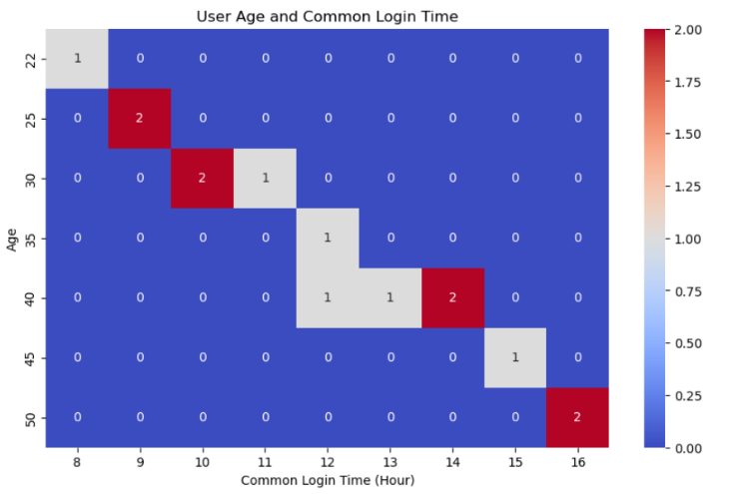**- Graph 1**: ‘User Age and Common Login Time’:

**- Graph 2**: ‘**Profile Completeness and Engagement**’

**Conclusions and Recommendations**

Based on the findings, it is clear that user engagement is closely tied to profile completeness and timing of app usage. To improve user interaction and satisfaction, the following recommendations are made:

* Encourage users to complete their profiles by adding more photos and detailed information, possibly through incentives like visibility boosts.
* Optimize app notifications to prompt users to engage during peak hours (9 AM - 10 AM).
* Consider targeted marketing efforts towards younger demographics, who show higher engagement levels on the platform.

**A few important points:**

1. The dataset was taken from a file repository called Kaggle, but several columns have been modified.
2. New columns containing random data have been added, so some conclusions may vary depending on the current execution of the code.
3. All conclusions and recommendations are based solely on this project, which, as mentioned, does not contain real information.